Internship Report – Day 2

Objective
To expand my creative and technical toolkit by installing and exploring OBS Studio, GIMP, FFmpeg, Inkscape, and Autodesk Fusion (Student Version), and to understand how these tools can be applied to internship projects, documentation, and GitHub workflows.

Tools Used
- OBS Studio – for recording and streaming project demos
- GIMP – for raster image editing and asset creation
- FFmpeg – for audio/video conversion, compression, and optimization
- Inkscape – for vector graphics and diagrams
- Autodesk Fusion (Student) – for 3D modeling, simulation, and rendering
- GitHub – for storing and sharing project assets

Steps & Evidence

Step 1: Installing OBS Studio
I downloaded and installed OBS Studio.
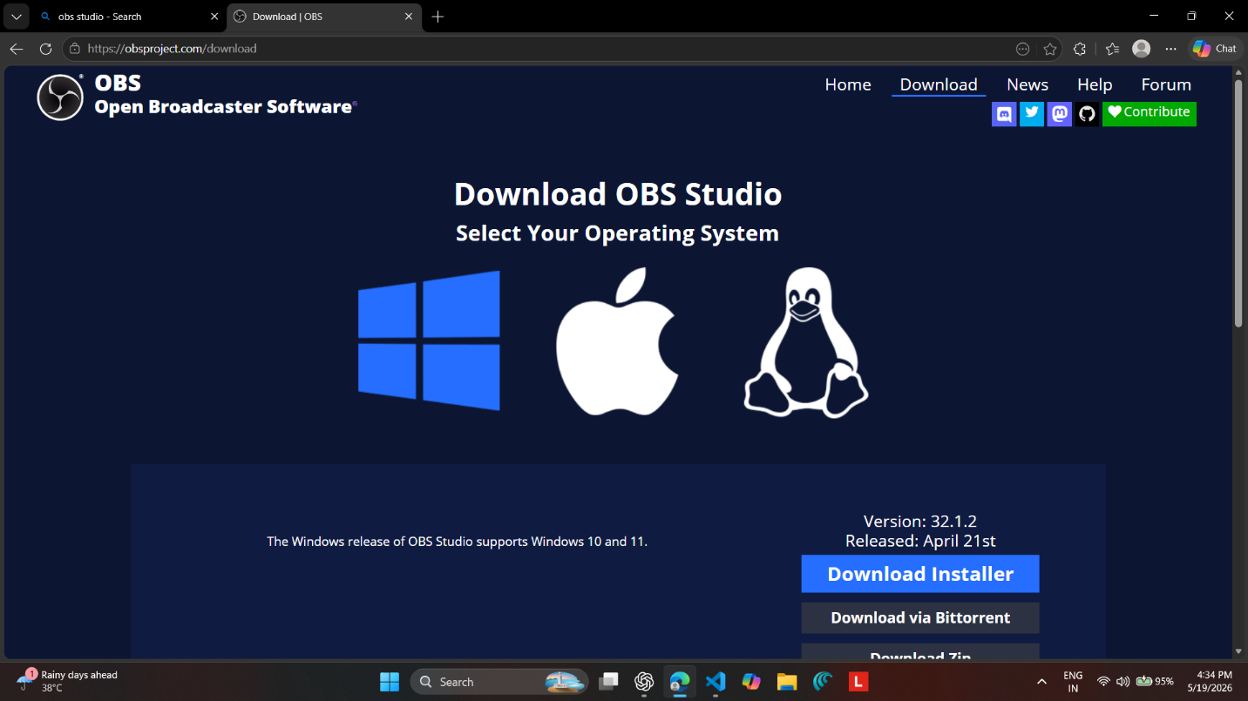Uses: Screen recording, live streaming, scene management, audio mixing, and professional documentation.
Applications: Record coding sessions, demos, and tutorials; upload optimized recordings to GitHub repositories.

Step 2: Installing GIMP
I installed GIMP for image editing.
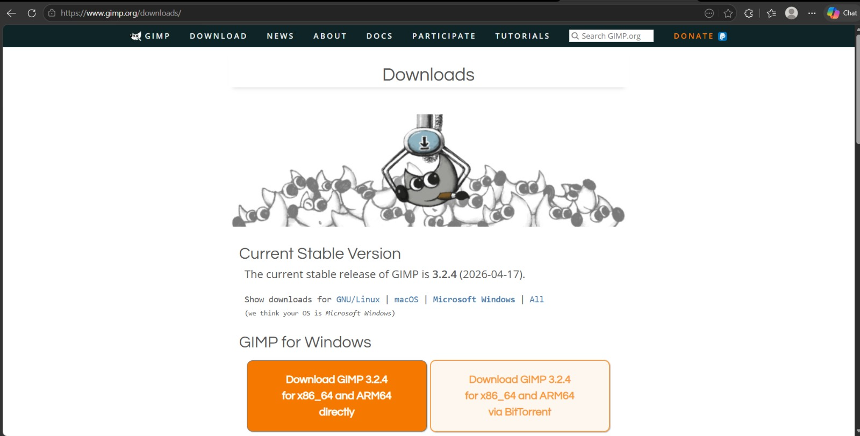
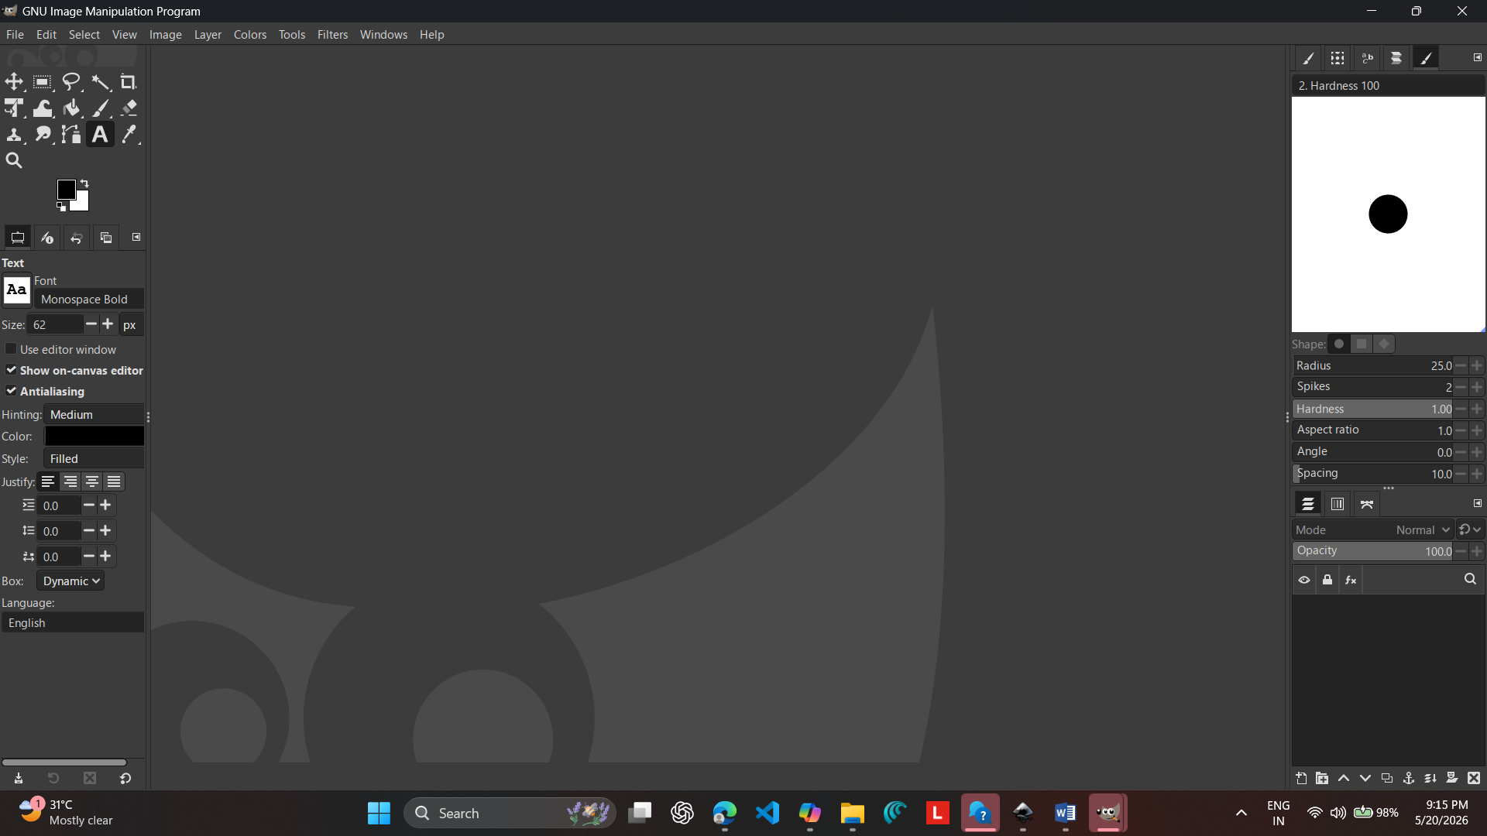
Uses: Photo editing, logo design, graphic creation, layer management, and export options.
Applications: Enhance portfolio visuals, edit screenshots for GitHub documentation, design logos for projects.

Step 3: Installing FFmpeg
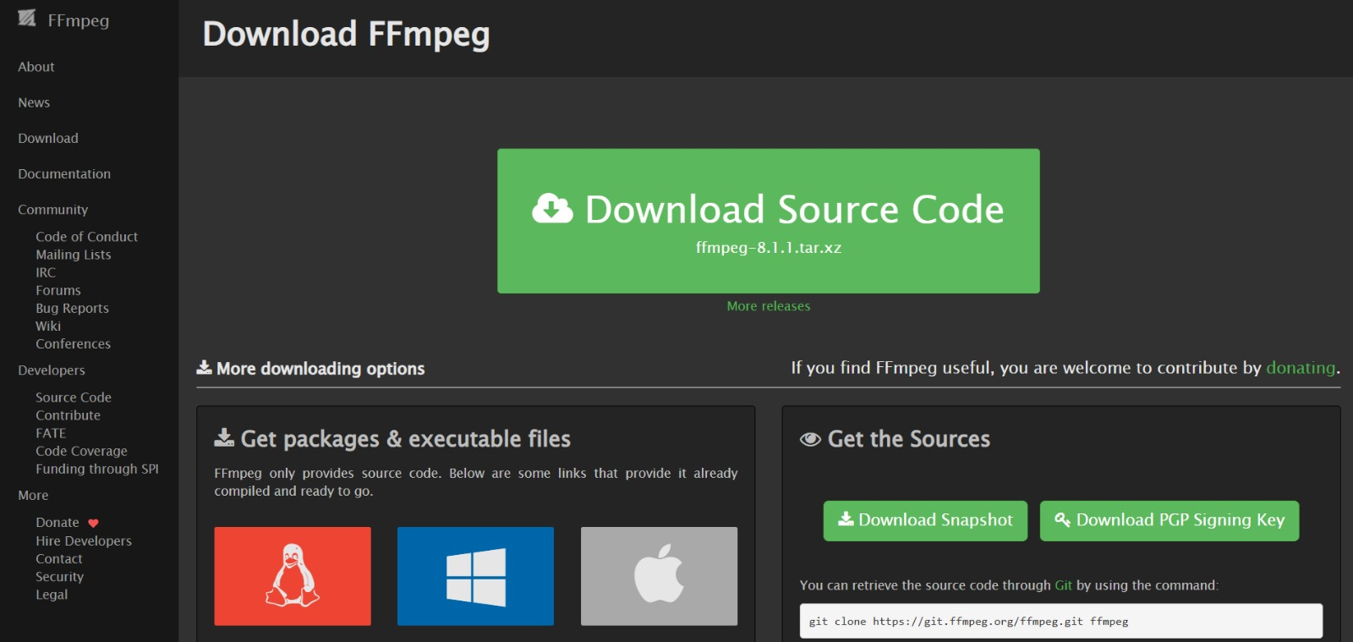
I installed FFmpeg for multimedia processing.

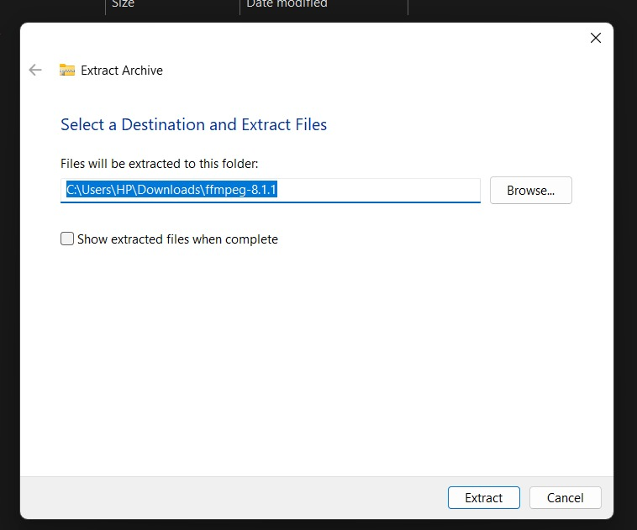

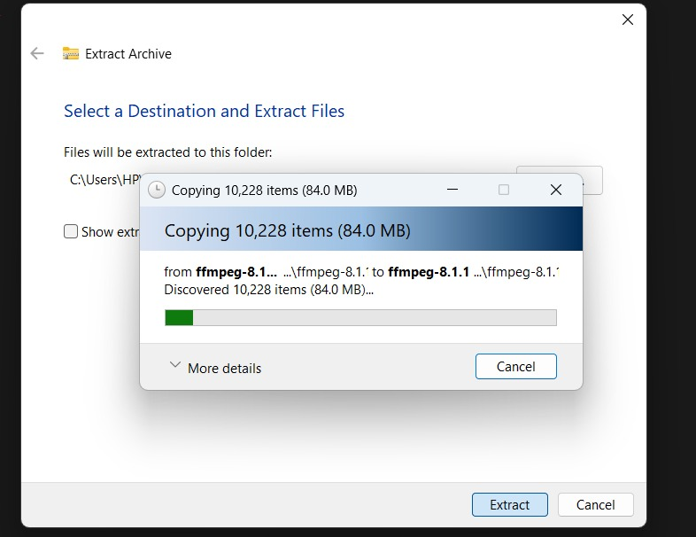

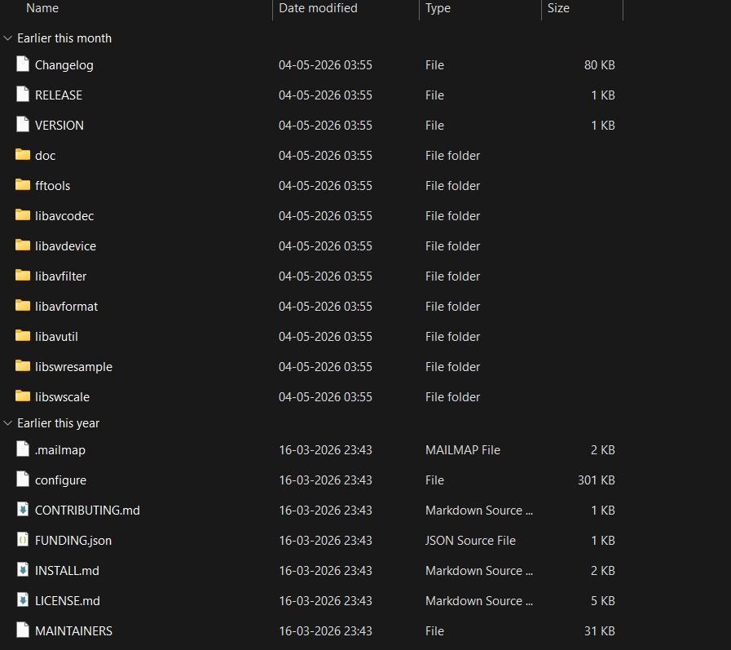

Uses: Format conversion, compression, audio extraction, resizing/scaling, streaming, and batch processing.
Applications: Compress OBS recordings, prepare lightweight videos for portfolio website, automate media workflows.

Step 4: Installing Inkscape
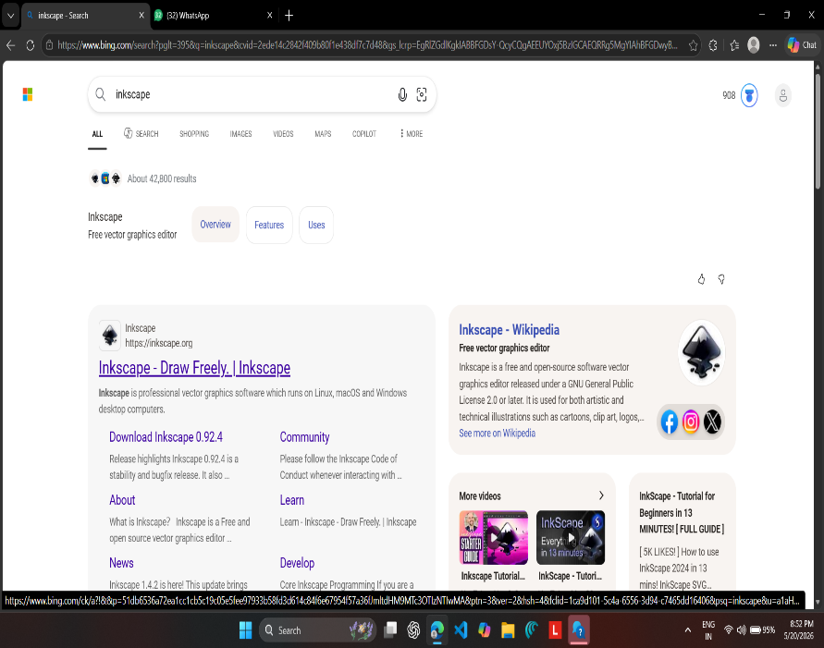
I installed Inkscape for vector graphics.

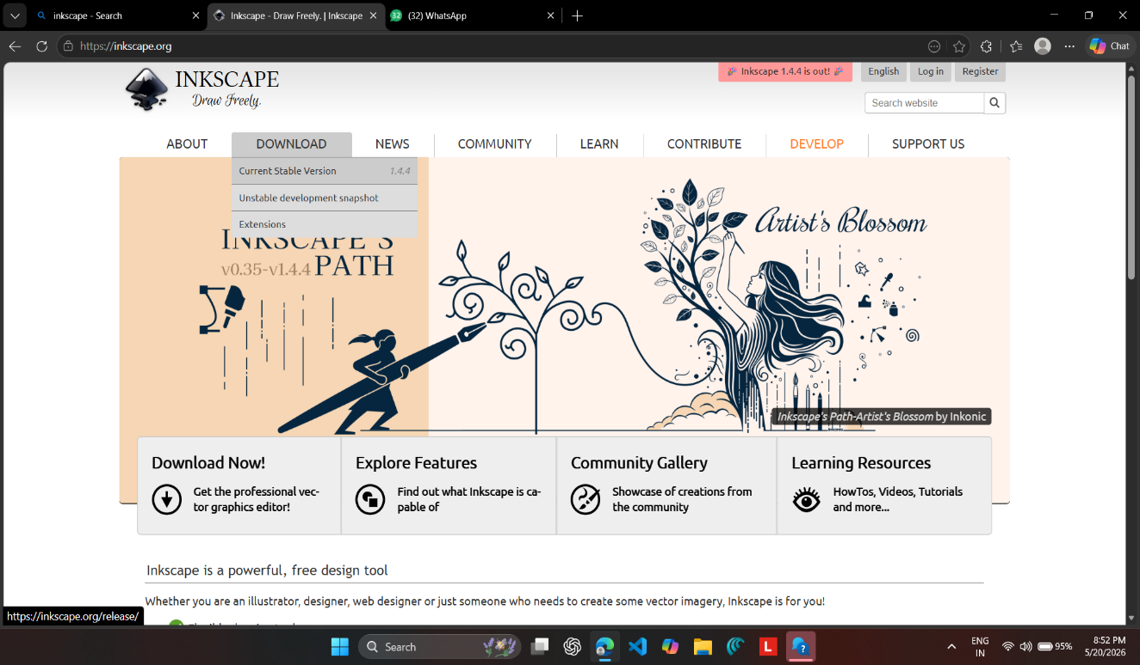

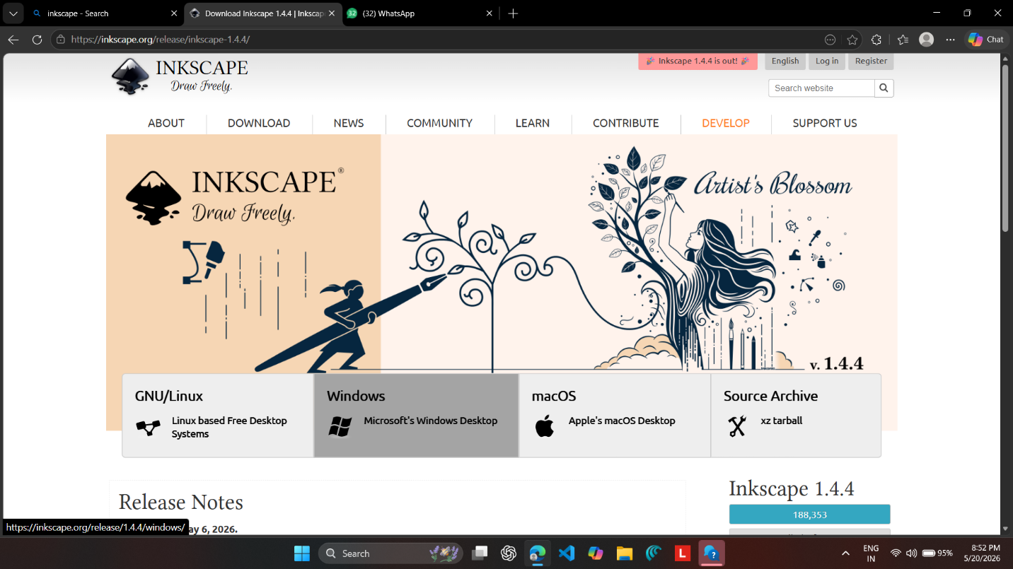
Uses: Vector graphics creation, diagram design, SVG editing, typography, and layered object management.
Applications: Create scalable logos, flowcharts, and diagrams for GitHub documentation and internship reports.

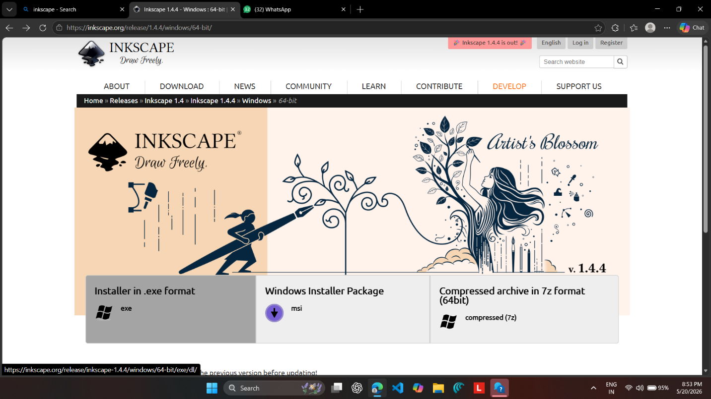

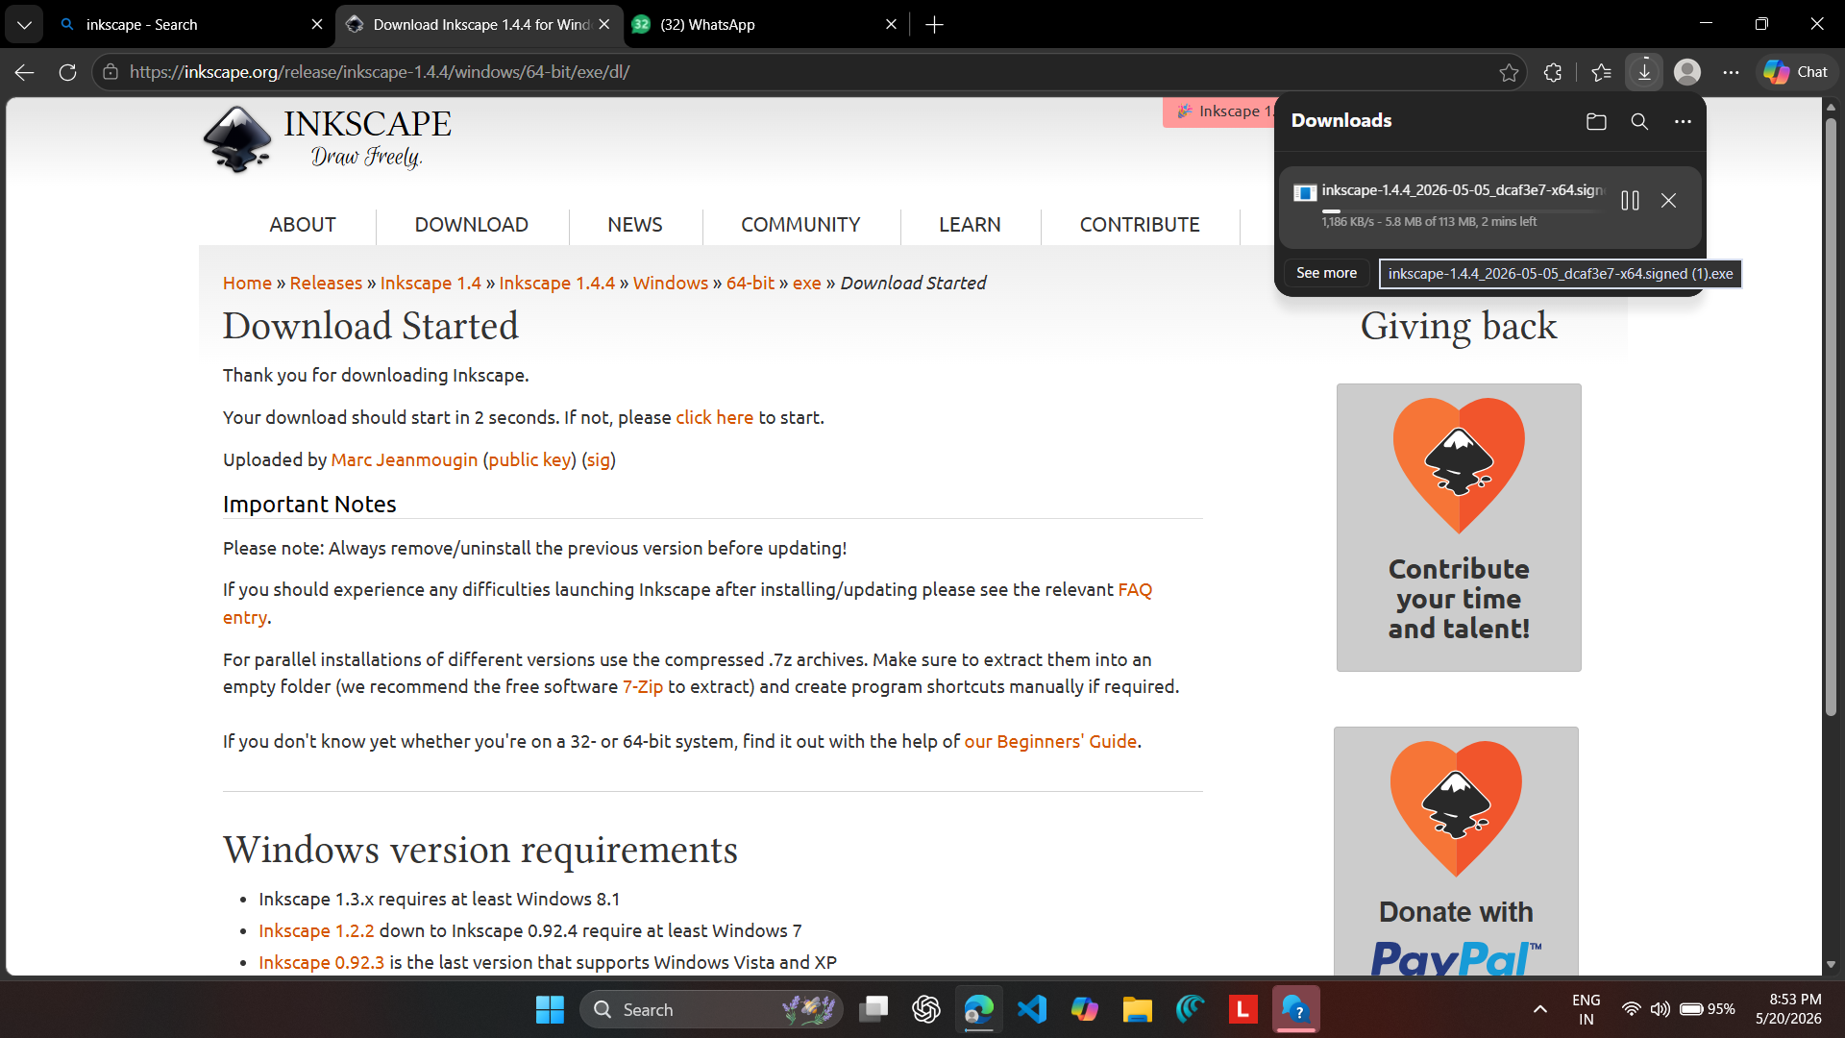

Step 5: Installing Autodesk Fusion (Student Version)
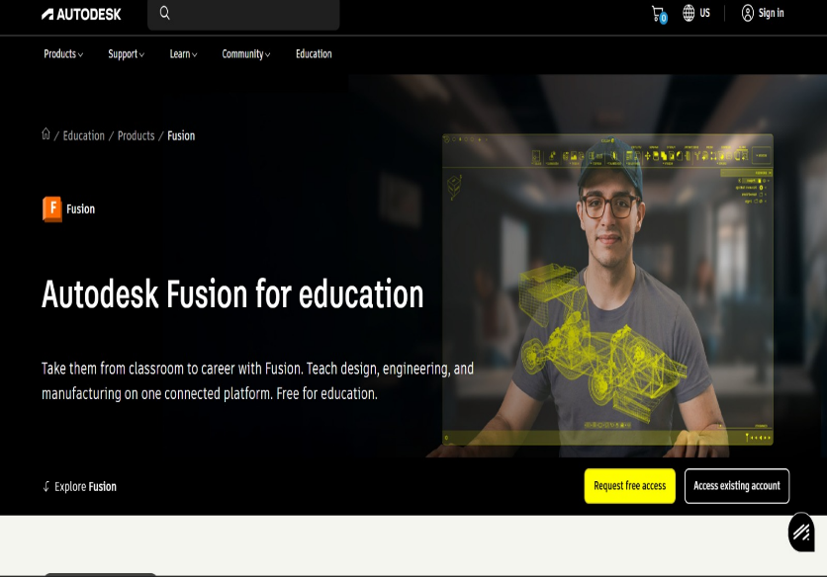
I installed Autodesk Fusion with a student license.
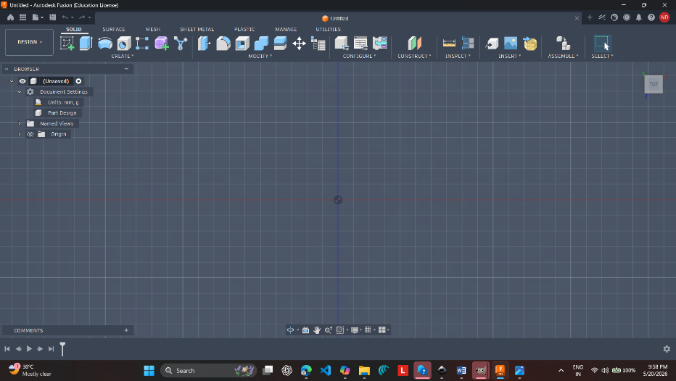
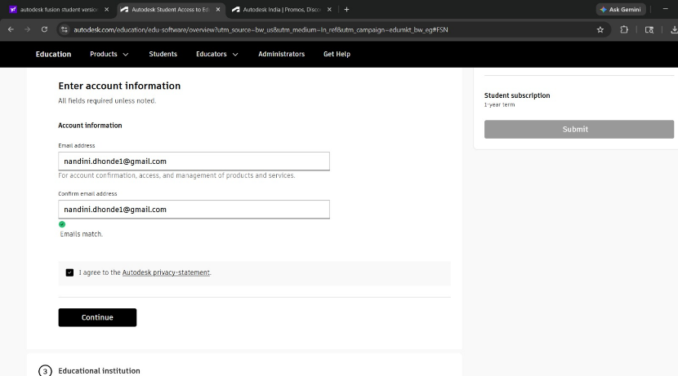
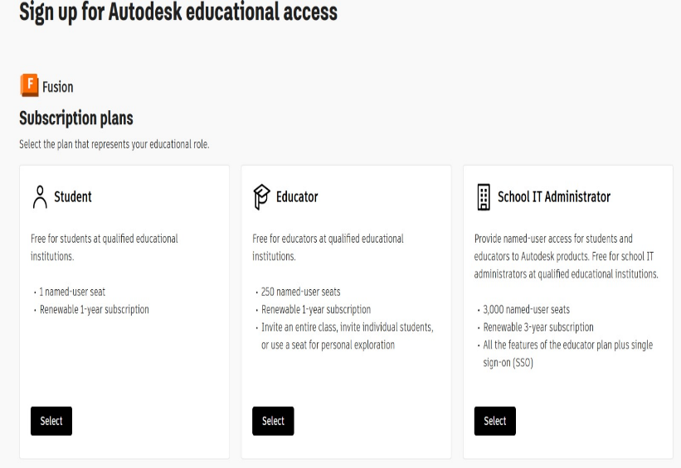

Uses: 3D modeling, simulation, CAM toolpaths, rendering, and collaboration.
Applications: Showcase 3D prototypes in portfolio website, upload CAD files to GitHub, include rendered visuals in internship reports.

Outcome
- Successfully installed and explored five new tools.
- Learned their core features and applications.
- Connected each tool to GitHub projects, portfolio enhancement, and internship documentation.

Reflection
Day 2 gave me a complete creative + technical toolkit:
- OBS Studio for recording.
- GIMP for raster image editing.
- FFmpeg for optimizing media.
- Inkscape for vector graphics.
- Autodesk Fusion for 3D modeling and simulation.
Together, these tools allow me to record, edit, optimize, design, and simulate projects, making my internship work professional, collaborative, and future-ready.

